Using DLP-USB245M

USB to FIFO Parallel Interface Module

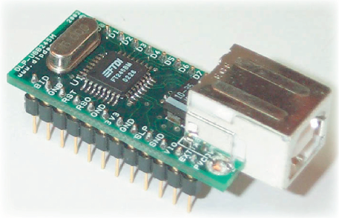

By
Sajjad Hussain, S.E.

1st March 2010
DLP-USB245M
Brief Procedure to Read and Write

The DLP-USB245M provides an easy cost-effective method of transferring data to / from a peripheral and a host at up to 8 Million bits (1-Megabyte) per second. There are two different methods to read/write data to DLP-USB245M.
- Using Virtual COM Port Drivers (VCP Driver)
- Using DLL Drivers (D2XX Driver)
These drivers are available as separate files and also available in Combined Driver Model (CDM). We will use the CDM driver i.e. both the D2XX and VCP drivers are installed, see the application note “FTDI Drivers Installation guide for Windows XP”.By using FTDI’s virtual COM Port drivers, the peripheral looks like a standard COM Port to the application software. Commands to set the baud rate are ignored – the device always transfers data at its fastest rate regardless of the application’s baud rate setting.
The DLP module is interfaced using AT89C2051 microcontroller as described in the following figure. Any character typed at the virtual com port of the DLP-USB245M is echoed back and transmitted to serial port of the PC.
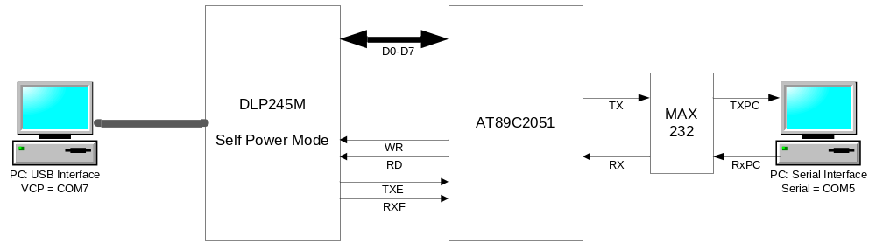Figure 1: DLP-Prototype Board

Applications
- High Speed Data Transfer
- Replacement for RS232 Interface
- Can transfer data serially using USB ports (Serial to USB converter)
- Interface using VCP and DLL Drivers
- Hot swappable

VCP Driver Interface
- Download the latest CDM driver from the DLP or FTDI website.
- Connect the DLP-Board to PC through USB Cable.
- Power up the DLP-Board, “New Hardware Found” wizard will prompt for the appropriate driver.
- Set the path to the CDM driver downloaded at your Hard Disk.
- Wait till the driver is completely installed and DLP-USB245M is ready to use.
- The driver assign un-used COM Port number to the Virtual COM port of the DLP-USB245M (COM7 here), see figure.
- Open the COM Port 7 on a serial terminal utility.
- Open the COM Port5 on another serial terminal utility, and set the baud rate to 19200 bps.
- Type any character at COM Port 7, this will be echoed back on COM 7 and also transmitted to COM 5. See Figure.

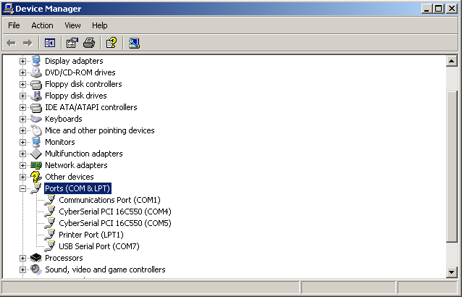
Figure 2: Available COM Ports (Physical and Virtual)

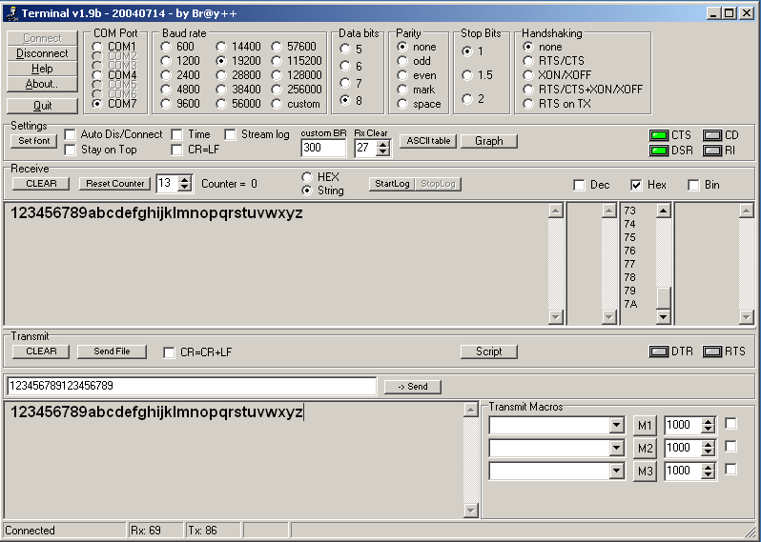
Figure 3: Virtual COM Port associated to DLP

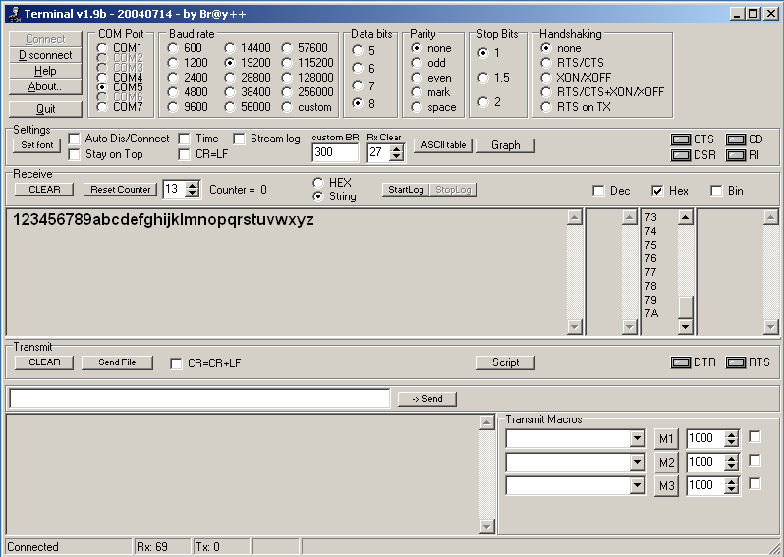
Figure 4: PC Serial COM Port

AT89C2051 C Code
The Microcontroller’s code is listed below:

void PrintChar(unsigned char c)
{

TI=1;
while (!TI); TI=0; SBUF = c;
while (!TI); TI=0;
}
void PrintString(char *s)
{
while (*s)
{
PrintChar(*s);
s++;
}
}
unsigned char DLP_Read(void)
{
unsigned char q;
if(!RXF)
{
P1 = 0xFF;
_nop_();
_nop_();
RD = 0;
q = P1;
_nop_();
_nop_();
RD = 1;
return q;
}
}

void DLP_Send(unsigned char s)
{
if(!TXE)
{
//WR = 1;
P1 = 0x00;
_nop_();
P1 = s;
_nop_();
WR = 0;
_nop_();
_nop_();
WR = 1;
P1 = 0xFF;
}
}

void main(void)
{
unsigned char temp;
SCON = 0x50;
TMOD = 0x21;
TL1 = 0xFD;
TH1 = 0xFD;
TR1 = 1;
EX0 = 1;
IT0 = 1;
ES = 1;
EA = 1;
RD = 1;
WR = 1;

while(1)
{
if(flag)
{
flag = 0;
temp = DLP_Read();
PrintChar(temp);
Txflag = 1;
}
if(Txflag)
{
Txflag = 0;
DLP_Send(temp);
}
}//while
}//main
void Recieve_EX0() interrupt 0
{
flag = 1;
}
void Serial() interrupt 4
{
if (RI)
{
RI = 0;
rxChr = SBUF;
PrintChar(rxChr);
rxflag = 1;
}//End if
}

D2XX Driver Interface
Write the interfacing code in any language (VC++) here, in which the DLL is called and used to open, read, write and close the DLP-USB245M module.
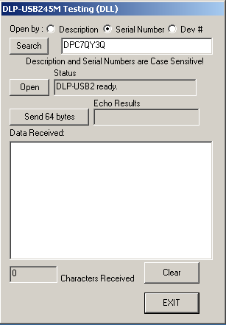
Figure 5: Testing D2XX driver in VC++

The DLP device can be opened using its description, serial number or device number. The device is automatically opened while loading the main form. One can open the DLP module again by Open button. The Search button is used to list the attached DLP devices to the computer. The Send 64 Bytes button is used to send the 64 bytes for testing.
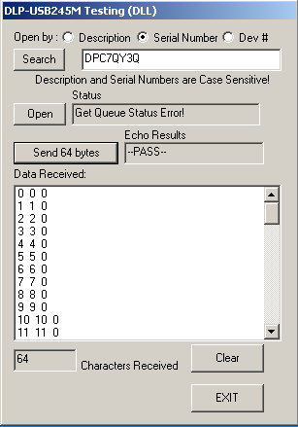
Figure 6: Send 64 Bytes for Testing
The serial port is used to send different commands to DLP-USB245M. For example send ‘A’ will cause DLP-USB245M to send characters from ‘A’ to ‘F’. Sending ‘B’ will cause DLP-USB245M to send 900 bytes.
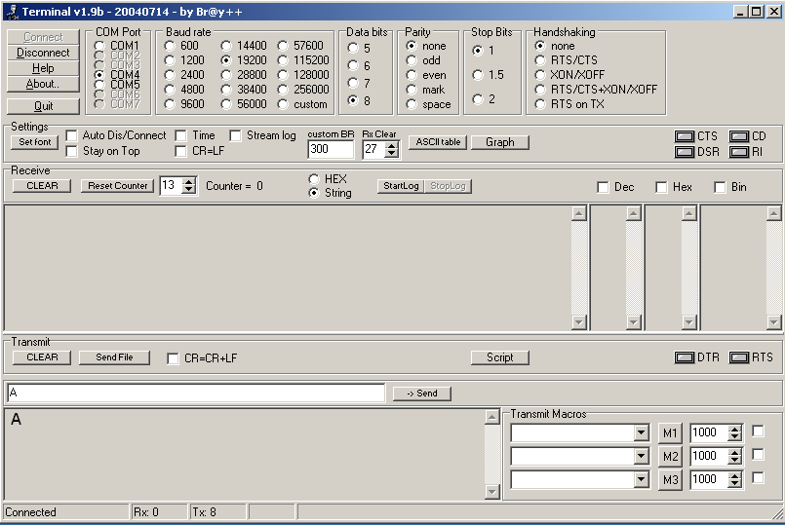
Figure 7: Send Command 'A' to DLP-USB Board
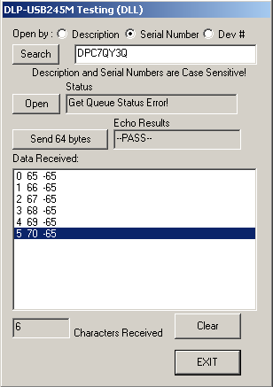
Figure 8: Response from DLP-USB Module
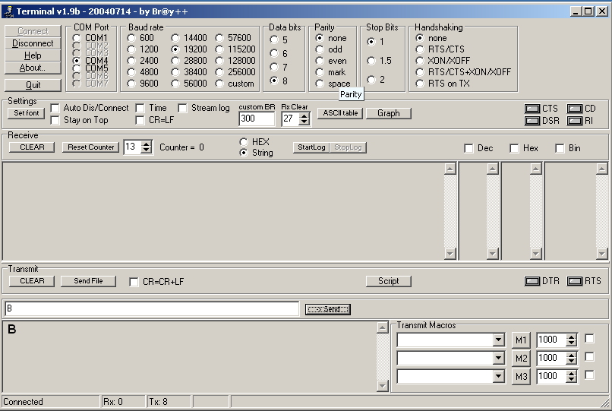
Figure 9: Send Command 'B' to DLP-USB Board
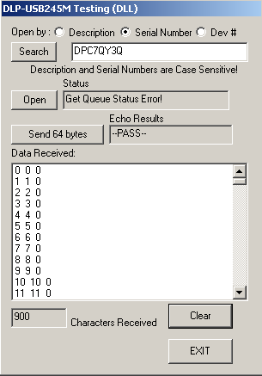
Figure 10: Response from DLP-USB Module

AT89C2051 C Code

void PrintChar(unsigned char c)
{

TI=1;
while (!TI); TI=0; SBUF = c;
while (!TI); TI=0;
}
void PrintString(char *s)
{
while (*s)
{
PrintChar(*s);
s++;
}
}
unsigned char DLP_Read(void)
{
unsigned char q;
if(!RXF)
{
P1 = 0xFF;
//_nop_();
//_nop_();
RD = 0;
q = P1;
//_nop_();
//_nop_();
RD = 1;
return q;
}
}

void DLP_Send(unsigned char s)
{
if(!TXE)
{
P1 = 0x00;
//_nop_();
P1 = s;
_nop_();
WR = 0;
//_nop_();
//_nop_();
WR = 1;
P1 = 0xFF;
}
}

void main(void)
{
unsigned char temp;
unsigned char cnt=0;
SCON = 0x50;
TMOD = 0x21;
TL1 = 0xFD;
TH1 = 0xFD;
TR1 = 1;
EX0 = 1;
IT0 = 1;
ES = 1;
EA = 1;
RD = 1;
WR = 1;

while(1)
{
if(flag)
{
flag = 0;
temp = DLP_Read();
//PrintChar(temp);
Txflag = 1;
}
if(Txflag)
{
Txflag = 0;
DLP_Send(temp);
}
}//while
}//main
void Recieve_EX0() interrupt 0
{
flag = 1;
}
void Serial() interrupt 4
{
if (RI)
{
RI = 0;
rxChr = SBUF;
rxflag = 1;
switch(rxChr)
{
case 'A':
DLP_Send('A');
DLP_Send('B');
DLP_Send('C');
DLP_Send('D');
DLP_Send('E');
DLP_Send('F');
break;
case 'B':
for(cnt=0;cnt<225;cnt++)
DLP_Send(cnt);
for(cnt=0;cnt<225;cnt++)
DLP_Send(cnt);
for(cnt=0;cnt<225;cnt++)
DLP_Send(cnt);
for(cnt=0;cnt<225;cnt++)
DLP_Send(cnt);
break;
default:
break;
}
}//End if
}

Visual C++ 6.0 Code
BOOL CUSBtestDlg::OnInitDialog()
{
CDialog::OnInitDialog();

// Add "About..." menu item to system menu.

// IDM_ABOUTBOX must be in the system command range.
ASSERT((IDM_ABOUTBOX & 0xFFF0) == IDM_ABOUTBOX);
ASSERT(IDM_ABOUTBOX < 0xF000);

CMenu* pSysMenu = GetSystemMenu(FALSE);
if (pSysMenu != NULL)
{
CString strAboutMenu;
strAboutMenu.LoadString(IDS_ABOUTBOX);
if (!strAboutMenu.IsEmpty())
{
pSysMenu->AppendMenu(MF_SEPARATOR);
pSysMenu->AppendMenu(MF_STRING, IDM_ABOUTBOX, strAboutMenu);
}
}

// Set the icon for this dialog. The framework does this automatically
// when the application's main window is not a dialog
SetIcon(m_hIcon, TRUE); // Set big icon
SetIcon(m_hIcon, FALSE); // Set small icon

// TODO: Add extra initialization here

recd = 0;
//m_SerDesc = 0;
//m_NameNmbr = "DLP-USB245M";

m_SerDesc = 1;
m_NameNmbr = "DPC7QY3Q";

//m_SerDesc = 2;
//m_NameNmbr = "0";

UpdateData(FALSE);

Loadem();//load DLL and test for presense of DLP-USB1 and DLP-USB2

return TRUE; // return TRUE unless you set the focus to a control
}
//****************************************************************************
UINT ThreadProc1(LPVOID param)//count up thread
{
//typecast the handle to the parent window
CUSBtestDlg *pMyHndl = (CUSBtestDlg *)param;

unsigned char cnt=0;
DWORD ret_bytes;
FT_STATUS status;
DWORD bytes_in_buf2;
unsigned char rx[600];

while(running)
{
Sleep(1);
status = pMyHndl->GetQueueStatus(&bytes_in_buf2);
if(status == FT_OK)
{
pMyHndl->m_PortStatus = _T("Get Queue Status Error!");
pMyHndl->UpdateData(FALSE);
}
if(bytes_in_buf2)
{
status = pMyHndl->Read(rx, bytes_in_buf2<600 ? bytes_in_buf2 : 600, &ret_bytes);
if((status == FT_OK) || ((status == FT_IO_ERROR) && (ret_bytes > 0)) /* Read timeout */)
{
if(ret_bytes)
{
CString str;
pMyHndl->UpdateData(TRUE);
for(DWORD x=0; x<ret_bytes; x++)
{
pMyHndl->m_NumRecd++;
str.Format("%d \t %d \t %d", pMyHndl->recd, rx[x], (pMyHndl->recd)%225 - rx[x]);
pMyHndl->recd++;
pMyHndl->myfstream<<str<<"\n";
pMyHndl->m_Received.AddString(str);
}
}
}
pMyHndl->UpdateData(FALSE);
pMyHndl->UpdateWindow();
}
}
return 0;
}

//**********************************************************************************
void CUSBtestDlg::OnOK()
{
//terminate the thread

myfstream.close ();
Close();
FreeLibrary(m_hmodule);

CDialog::OnOK();
}
//**********************************************************************************
void CUSBtestDlg::OnButtonSend64Echo()
{
//send 64 bytes and verify each is echoed back correctly

//unsigned char tx[3], rx[3];
int t;
DWORD ret_bytes;

running = 1;
AfxBeginThread(ThreadProc1, this, THREAD_PRIORITY_NORMAL);
GetDlgItem(IDOK)->EnableWindow(FALSE);

UpdateData(TRUE);
m_EchoRes = _T("Testing...");
UpdateData(FALSE);
UpdateWindow();

//clear the ports of any data
Purge(FT_PURGE_RX || FT_PURGE_TX);

m_EchoRes = _T("--PASS--");
for(t=0; t<64; t++)
{
txbuf[0] = t;
Write(txbuf, 1, &ret_bytes);

}
UpdateData(FALSE);
UpdateWindow();

//bus_busy=0;

GetDlgItem(IDOK)->EnableWindow(TRUE);
}
//****************************************************************************
BOOL CUSBtestDlg::OnCommand(WPARAM wParam, LPARAM lParam) //disable the ESC key
{
if(wParam==2) return FALSE;
return CDialog::OnCommand(wParam, lParam);
}
//*******************************************************************
void CUSBtestDlg::OnButtonClear()
{
UpdateData(TRUE);
m_NumRecd=0;
recd = 0;
m_Received.ResetContent();
UpdateData(FALSE);
UpdateWindow();
}
//***************************************************************************************
void CUSBtestDlg::OnRadioNameNum()
{
m_SerDesc = 0;
m_NameNmbr = "DLP-USB245M";

UpdateData(FALSE);
}
//***************************************************************************************
void CUSBtestDlg::OnRadioSernum()
{
m_SerDesc = 1;
m_NameNmbr = "DPC7QY3Q";

UpdateData(FALSE);
}
//***************************************************************************************
void CUSBtestDlg::OnRadioDevno()
{
m_SerDesc = 2;
m_NameNmbr = "0";

UpdateData(FALSE);
}
//***************************************************************************************
void CUSBtestDlg::Loadem()
{
DWORD ret_bytes;
LoadDLL();

UpdateData(TRUE);

//open the device
FT_STATUS status = OpenBy();
if(status)
m_PortStatus = _T("USB1 not responding");
else
{
ResetDevice();
///SetTimeouts(3000, 3000);//extend timeout while board DLP-USB2 finishes reset
Purge(FT_PURGE_RX || FT_PURGE_TX);
//test for presence of board
txbuf[0] = 0x80;
Write(txbuf, 1, &ret_bytes);
Read(rxbuf, 1, &ret_bytes);
if(ret_bytes==0)//if no response maybe windows was busy... read it again
Read(rxbuf, 1, &ret_bytes);
if(rxbuf[0] != 0x80)
{
m_PortStatus = _T("No response from DLP-USB2");
CString str;
str.Format("%d 0x%.2X", rxbuf[0], rxbuf[0]);
m_PortStatus += str;
}
else
{
m_PortStatus = _T("DLP-USB2 ready.");

}
}

SetTimeouts(300, 300);
UpdateData(FALSE);
UpdateWindow();
}

//***************************************************************************************
FT_STATUS CUSBtestDlg::OpenBy()
{
UpdateData(TRUE);
myfstream.open("logfile.txt",ios::in|ios::out,filebuf::sh_read);

if(m_NameNmbr.Find("Enter device Description") > -1)
{
//highlight the descriptor/serial number to draw attention...
CEdit *pEdt;
pEdt = (CEdit *)GetDlgItem(IDC_EDIT_NAME_NUMBER);
pEdt->SetFocus();
pEdt->SetSel(0, -1, FALSE);
AfxMessageBox("You must enter a Device Description or Serial Number.");
return FT_DEVICE_NOT_OPENED;
}

FT_STATUS status;
ULONG x=0;
if(m_SerDesc==0)
status = OpenEx((PVOID)(LPCTSTR)m_NameNmbr, FT_OPEN_BY_DESCRIPTION);
if(m_SerDesc==1)
status = OpenEx((PVOID)(LPCTSTR)m_NameNmbr, FT_OPEN_BY_SERIAL_NUMBER);
if((m_SerDesc==2) || (m_SerDesc==-1))//if open by device OR no method was selected
{
if(m_NameNmbr.GetLength() < 1)//nothing entered - open default device 0
{
status = Open((PVOID)x);//load default device 0
}
else
{
if(m_NameNmbr.GetLength() > 2)//no Open() method selected...
{
AfxMessageBox("Select a method to open or enter a valid device number (0-64).");
return FT_DEVICE_NOT_OPENED;
}

//convert string to decimal number and open(x)
char str[3];
strcpy(str, (LPCTSTR)m_NameNmbr);
x = atoi(str);
if((x<0) || (x>64))
{
AfxMessageBox("Select a method to open or enter a valid device number (0-64).");
return FT_DEVICE_NOT_OPENED;
}
status = Open((PVOID)x);
}
}

return status;
}
//***************************************************************************************
void CUSBtestDlg::OnButtonHello() //code for the "Open" button
{
//unsigned char txbuf[25], rxbuf[25];
DWORD ret_bytes;

UpdateData(TRUE);
m_PortStatus = _T("-reset-");
UpdateData(FALSE);
UpdateWindow();

Close();

//open the device
FT_STATUS status = OpenBy();
if(status>0)
{
m_PortStatus = _T("Could not open DLP-USB1");
//board_present=0;
}
else
{

ResetDevice();
Purge(FT_PURGE_RX || FT_PURGE_TX);
ResetDevice();
SetTimeouts(3000, 3000);//extend timeout while board finishes reset
Sleep(150);

//test for presence of board
txbuf[0] = 0x80;
Write(txbuf, 1, &ret_bytes);
Read(rxbuf, 1, &ret_bytes);
if(ret_bytes==0)
Read(rxbuf, 1, &ret_bytes);
if(rxbuf[0] != 0x80)
{
m_PortStatus = _T("DLP-USB2 not responding");
CString str;
str.Format("%d 0x%.2X", rxbuf[0], rxbuf[0]);
m_PortStatus += str;
Close();
}
else
m_PortStatus = _T("DLP-USB2 ready.");
}

SetTimeouts(300, 300);
UpdateData(FALSE);
UpdateWindow();
}
//***************************************************************************************
void CUSBtestDlg::OnButtonSearch()
{
//search for Descriptions or Serial Numbers depending on the current mode
FT_STATUS ftStatus;
DWORD numDevs;

Close();//must be closed to perform the ListDevices() function
UpdateData(TRUE);
m_PortStatus = _T("DLP-USB1 Closed.");
m_NumRecd=0;
//m_NameNmbr = _T("");
m_Received.ResetContent();
UpdateData(FALSE);
UpdateWindow();

ftStatus = ListDevices(&numDevs, NULL, FT_LIST_NUMBER_ONLY);
if(ftStatus == FT_OK)
{
// FT_ListDevices OK, show number of devices connected in list box
CString str;
str.Format("%d device(s) attached:", (int)numDevs);
m_Received.AddString(str);

//if current mode is open "by device #" then list device numbers
if((m_SerDesc==2) && (numDevs>0))
{
for(DWORD d=0; d<numDevs; d++)
{
str.Format("%d", d);
m_Received.AddString(str);
}

}

//if current mode is open "by description" then list descriptions of all connected devices
if((m_SerDesc==0) && (numDevs>0))
{
ftStatus = ListDevices(&numDevs, NULL, FT_LIST_NUMBER_ONLY);
if(ftStatus == FT_OK)
{
char *BufPtrs[64]; // pointer to array of 64 pointers
for(DWORD d=0; d<numDevs; d++)
BufPtrs[d] = new char[64];
BufPtrs[d] = NULL;

ftStatus = ListDevices(BufPtrs, &numDevs, FT_LIST_ALL|FT_OPEN_BY_DESCRIPTION);
if (FT_SUCCESS(ftStatus))
{
for(DWORD u=0; u<numDevs; u++)
{
str.Format("%s", BufPtrs[u]);
m_Received.AddString(str);
}
}
else
{
str.Format("ListDevices failed");
m_Received.AddString(str);
}

//free ram to avoid memory leaks
for(d=0; d<numDevs; d++)
{
delete BufPtrs[d];
}
}
}

//if current mode is open "by serial number" the list descriptions
//of all connected devices
if((m_SerDesc==1) && (numDevs>0))
{
//AfxMessageBox("by serial");
ftStatus = ListDevices(&numDevs, NULL, FT_LIST_NUMBER_ONLY);
if(ftStatus == FT_OK)
{
char *BufPtrs[64]; // pointer to array of 64 pointers
for(DWORD d=0; d<numDevs; d++)
BufPtrs[d] = new char[64];
BufPtrs[d] = NULL;

ftStatus = ListDevices(BufPtrs, &numDevs, FT_LIST_ALL|FT_OPEN_BY_SERIAL_NUMBER);
if (FT_SUCCESS(ftStatus))
{
for(DWORD u=0; u<numDevs; u++)
{
str.Format("%s", BufPtrs[u]);
m_Received.AddString(str);
}
}
else
{
str.Format("ListDevices failed");
m_Received.AddString(str);
}

//free ram to avoid memory leaks
for(d=0; d<numDevs; d++)
delete BufPtrs[d];
}
}

}
else
{
// FT_ListDevices failed
AfxMessageBox("FT_ListDevices failed");
}
}
//***************************************************************************************
void CUSBtestDlg::LoadDLL()
{
m_hmodule = LoadLibrary("Ftd2xx.dll");
if(m_hmodule == NULL)
{
AfxMessageBox("Error: Can't Load ft8u245.dll");
return;
}

m_pWrite = (PtrToWrite)GetProcAddress(m_hmodule, "FT_Write");
if (m_pWrite == NULL)
{
AfxMessageBox("Error: Can't Find FT_Write");
return;
}

m_pRead = (PtrToRead)GetProcAddress(m_hmodule, "FT_Read");
if (m_pRead == NULL)
{
AfxMessageBox("Error: Can't Find FT_Read");
return;
}

m_pOpen = (PtrToOpen)GetProcAddress(m_hmodule, "FT_Open");
if (m_pOpen == NULL)
{
AfxMessageBox("Error: Can't Find FT_Open");
return;
}

m_pOpenEx = (PtrToOpenEx)GetProcAddress(m_hmodule, "FT_OpenEx");
if (m_pOpenEx == NULL)
{
AfxMessageBox("Error: Can't Find FT_OpenEx");
return;
}

m_pListDevices = (PtrToListDevices)GetProcAddress(m_hmodule, "FT_ListDevices");
if(m_pListDevices == NULL)
{
AfxMessageBox("Error: Can't Find FT_ListDevices");
return;
}

m_pClose = (PtrToClose)GetProcAddress(m_hmodule, "FT_Close");
if (m_pClose == NULL)
{
AfxMessageBox("Error: Can't Find FT_Close");
return;
}

m_pResetDevice = (PtrToResetDevice)GetProcAddress(m_hmodule, "FT_ResetDevice");
if (m_pResetDevice == NULL)
{
AfxMessageBox("Error: Can't Find FT_ResetDevice");
return;
}

m_pPurge = (PtrToPurge)GetProcAddress(m_hmodule, "FT_Purge");
if (m_pPurge == NULL)
{
AfxMessageBox("Error: Can't Find FT_Purge");
return;
}

m_pSetTimeouts = (PtrToSetTimeouts)GetProcAddress(m_hmodule, "FT_SetTimeouts");
if (m_pSetTimeouts == NULL)
{
AfxMessageBox("Error: Can't Find FT_SetTimeouts");
return;
}

m_pGetQueueStatus = (PtrToGetQueueStatus)GetProcAddress(m_hmodule, "FT_GetQueueStatus");
if (m_pGetQueueStatus == NULL)
{
AfxMessageBox("Error: Can't Find FT_GetQueueStatus");
return;
}
}
//***************************************************************************************
FT_STATUS CUSBtestDlg::Read(LPVOID lpvBuffer, DWORD dwBuffSize, LPDWORD lpdwBytesRead)
{
if (!m_pRead)
{
AfxMessageBox("FT_Read is not valid!");
return FT_INVALID_HANDLE;
}

return (*m_pRead)(m_ftHandle, lpvBuffer, dwBuffSize, lpdwBytesRead);
}

//***************************************************************************************
FT_STATUS CUSBtestDlg::Write(LPVOID lpvBuffer, DWORD dwBuffSize, LPDWORD lpdwBytes)
{
if (!m_pWrite)
{
AfxMessageBox("FT_Write is not valid!");
return FT_INVALID_HANDLE;
}

return (*m_pWrite)(m_ftHandle, lpvBuffer, dwBuffSize, lpdwBytes);
}
//***************************************************************************************
FT_STATUS CUSBtestDlg::Open(PVOID pvDevice)
{
if (!m_pOpen)
{
AfxMessageBox("FT_Open is not valid!");
return FT_INVALID_HANDLE;
}

return (*m_pOpen)(pvDevice, &m_ftHandle );
}
//***************************************************************************************
FT_STATUS CUSBtestDlg::OpenEx(PVOID pArg1, DWORD dwFlags)
{
if (!m_pOpenEx)
{
AfxMessageBox("FT_OpenEx is not valid!");
return FT_INVALID_HANDLE;
}

return (*m_pOpenEx)(pArg1, dwFlags, &m_ftHandle);
}
//***************************************************************************************
FT_STATUS CUSBtestDlg::ListDevices(PVOID pArg1, PVOID pArg2, DWORD dwFlags)
{
if (!m_pListDevices)
{
AfxMessageBox("FT_ListDevices is not valid!");
return FT_INVALID_HANDLE;
}

return (*m_pListDevices)(pArg1, pArg2, dwFlags);
}
//***************************************************************************************
FT_STATUS CUSBtestDlg::Close()
{
if (!m_pClose)
{
AfxMessageBox("FT_Close is not valid!");
return FT_INVALID_HANDLE;
}

return (*m_pClose)(m_ftHandle);
}
//***************************************************************************************
FT_STATUS CUSBtestDlg::ResetDevice()
{
if (!m_pResetDevice)
{
AfxMessageBox("FT_ResetDevice is not valid!");
return FT_INVALID_HANDLE;
}

return (*m_pResetDevice)(m_ftHandle);
}
//***************************************************************************************
FT_STATUS CUSBtestDlg::Purge(ULONG dwMask)
{
if (!m_pPurge)
{
AfxMessageBox("FT_Purge is not valid!");
return FT_INVALID_HANDLE;
}

return (*m_pPurge)(m_ftHandle, dwMask);
}
//***************************************************************************************
FT_STATUS CUSBtestDlg::SetTimeouts(ULONG dwReadTimeout, ULONG dwWriteTimeout)
{
if (!m_pSetTimeouts)
{
AfxMessageBox("FT_SetTimeouts is not valid!");
return FT_INVALID_HANDLE;
}

return (*m_pSetTimeouts)(m_ftHandle, dwReadTimeout, dwWriteTimeout);
}
//***************************************************************************************
FT_STATUS CUSBtestDlg::GetQueueStatus(LPDWORD lpdwAmountInRxQueue)
{
if (!m_pGetQueueStatus)
{
AfxMessageBox("FT_GetQueueStatus is not valid!");
return FT_INVALID_HANDLE;
}

return (*m_pGetQueueStatus)(m_ftHandle, lpdwAmountInRxQueue);
}
